**Demonstrate how to set up Postman**

Open Browser then search postman download and download it

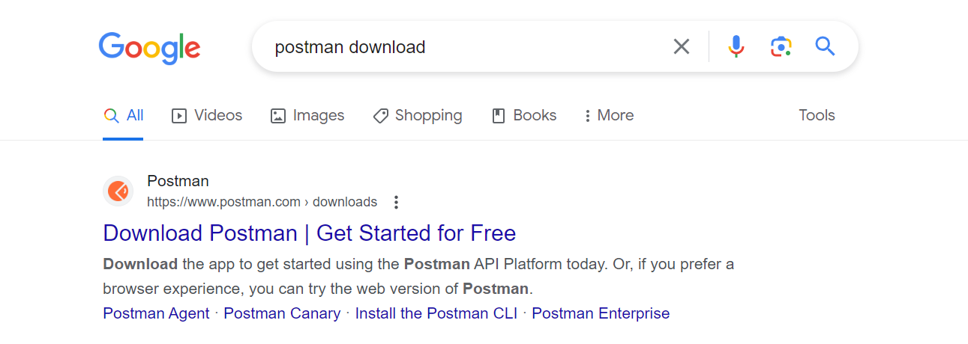

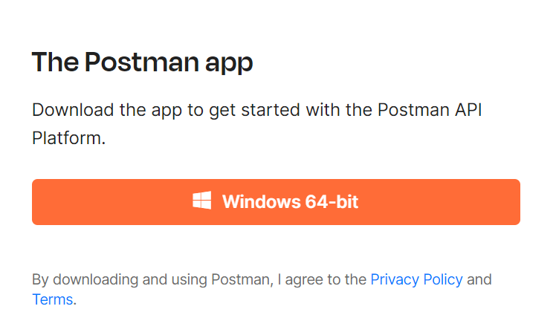

Then go to download folder and install it

